Building a Lex + Yacc Front-End for an Arithmetic Expression Language : A Case Study
Case study Report submitted in partial fulfilment of the requirements for the award of
the Degree of B.E in Computer Science and Engineering
By

Midde Puja  Mudakala Ujasvi  Ennala Sreenidhi  Shaik Afreen Tarunam  M. Anjali  R. Anusha | 160623733160  160623733162  160623733144  160623733176  160623733154  160623733167

Under the Guidance of
Assistant Professor, Department of Computer Science & Engineering


Department of Computer Science and Engineering
Stanley College of Engineering & Technology for
Women(Autonomous)
Chapel Road, Abids, Hyderabad – 500001
(Affiliated to Osmania University, Hyderabad, Approved by AICTE, Accredited by
NBA & NAAC with A Grade)

Stanley College of Engineering & Technology for Women
(Autonomous)
Chapel Road, Abids, Hyderabad – 500001
(Affiliated to Osmania University, Hyderabad, Approved by AICTE, Accredited
by NBA & NAAC with A Grade)

CERTIFICATE
This is to certify that case study report entitled Building a Lex + Yacc Front-End for an
Arithmetic Expression Language is being submitted By

Midde Puja  Mudakala Ujasvi  Ennala Sreenidhi  Shaik Afreen Tarunam  M. Anjali  R. Anusha | 160623733160  160623733162  160623733144  160623733176  160623733154  160623733167
In partial fulfilment for the award of the Degree of Bachelor of Engineering in Computer Science & Engineering to the Osmania University, Hyderabad is a record of bonafide work carried out under my guidance and supervision. The results embodied in this Problem statement report have not been submitted to any other University or Institute for the award of any Degree or Diploma.

Guide Head of the Department
Mrs. Gnana Prasuna Dr. R Madana Mohana
Professor, Dept. of CSE Professor & Head , Dept. of CSE

STANLEY COLLEGE OF ENGINEERING AND TECHNOLOGY FOR WOMEN
(Autonomous)
Chapel Road, Abids, Hyderabad.
Department of Computer Science & Engineering

Institute Vision:
Empowering girl students through professional integrated with values and character to make an
Impact in the world
Institute Mission:
M1: Enabling quality engineering education for girl students to make them competent and confident to succeed in professional practice and advanced learning.

M3: Integrating qualities like humanity, social values, ethics, leadership towards their contribution to society.
Department Vision:
Empowering girl students with the contemporary knowledge in Computer Science and Engineering for their success in life.
Department Mission:
M1: To impart quality education for girl students to learn and practice various hardware and software platforms prevalent in industry.
M2: To achieve self-sustainability and overall development through Research and Development activities.
M3: To provide education for life by focusing on the inculcation of human & moral values through and honest and scientific approach
M4: To groom students with good attitude, team work and personality skills.

Programme Educational Objectives
PEO1: Our graduates shall have enhanced skills and contemporary knowledge in software and hardware technologies for professional excellence, towards successful employment, advanced learning and research.

PEO2: Our graduates shall have life-long learning attitude, innovation and creativity to master latest technologies, devise solutions for realistic and social issues in the society.

PEO3: Our graduates have good attitude and personality skills, ethical values, teamwork and leadership skill towards professionalism and ethical practices within the organization and the society.

Program Outcomes:
PO1: Engineering Knowledge: Apply knowledge of mathematics and science, with fundamentals of Computer Science & Engineering to be able to solve complex engineering problems related to CSE.
PO2: Problem Analysis: Identify, Formulate, review research literature and analyze complex engineering problems related to CSE and reaching substantiated conclusions using first principles of mathematics, natural sciences and engineering sciences.
PO3: Design/Development of solutions: Design solutions for complex engineering problems related to CSE and design system components or processes that meet the specified needs with appropriate consideration for the public health and safety and the cultural societal and environmental considerations.
PO4: Conduct Investigations of Complex problems: Use research–based knowledge and research methods including design of experiments, analysis and interpretation of data, and synthesis of the information to provide valid conclusions.
PO5: Modern Tool Usage: Create, Select and apply appropriate techniques, resources and modern engineering and IT tools including prediction and modeling to computer science related complex engineering activities with an understanding of the limitations.
PO6: The Engineer and Society: Apply Reasoning informed by the contextual knowledge to assess societal, health, safety, legal and cultural issues and the consequent responsibilities relevant to the CSE professional engineering practice.
PO7: Environment and Sustainability: Understand the impact of the CSE professional engineering solutions in societal and environmental contexts and demonstrate the knowledge of, and need for sustainable development.
PO8: Ethics: Apply Ethical Principles and commit to professional ethics and responsibilities and norms of the engineering practice.
PO9: Individual and Team Work: Function effectively as an individual and as a member or leader in diverse teams and in multidisciplinary Settings.
PO10: Communication: Communicate effectively on complex engineering activities with the engineering community and with society at large such as able to comprehend and with write effective reports and design documentation, make effective presentations and give and receive clear instructions.
PO11: Problem statement Management and Finance: Demonstrate knowledge and understanding of the engineering management principles and apply these to one’s own work, as a member and leader in a team, to manage Problem statements and in multi disciplinary environments.
PO12: Life-Long Learning: Recognize the need for and have the preparation and ability to engage in independent and life-long learning the broadest context of technological change.

Program Specific outcomes:
PSO1: Problem-Solving Skills: The ability to apply standard practices and strategies in software Problem statement development using open-ended programming environments to deliver a quality product for the benefit of students.
PSO2: Design, Implement, Test and Evaluate a computer system, component or algorithm to meet desired needs and to solve a computational problem.

ABSTRACT

This case study focuses on the implementation of a compiler front-end, primarily handling the Lexical Analysis and Syntax Analysis phases for an arithmetic expression language. Utilizing token recognition techniques and parser construction methodologies, the project validates syntax and constructs abstract syntax trees for expression evaluation.
The system accepts arithmetic expressions as input, processes them by identifying tokens such as numbers and operators, validates their syntactic structure, and evaluates the result based on operator precedence and associativity rules. A graphical user interface (GUI) is developed using Java to enhance user interaction, allowing users to input expressions and view results in real time.
Although the implementation does not use actual Lex and Yacc tools, it effectively simulates their behavior through a recursive descent parsing approach. The project highlights key compiler design concepts and provides a clear understanding of how expressions are analyzed and evaluated internally. This work serves as an educational tool for students to grasp the working of compiler front-end components in a simplified environment.

Tables of Contents

- Introduction
  - About Problem statement
  - The primary objective is to design a front-end module capable of accurately tokenizing, parsing, and evaluating complex arithmetic expressions, resolving operator precedence, and validating syntactic structures in real-time.
  - Scope of the Problem statement
  - Advantages
  - Disadvantages
  - Applications
  - - Educational demonstrations of compiler front-end mechanics.
- Embedded systems requiring lightweight expression evaluation.
- Foundational component for domain-specific scripting languages.
- Implementation
  - Code Snippets Implementation
- Result Analysis
- The system successfully evaluated a variety of test cases, accurately identifying syntax errors in invalid expressions and correctly applying operator precedence rules to yield precise mathematical results for complex nested equations.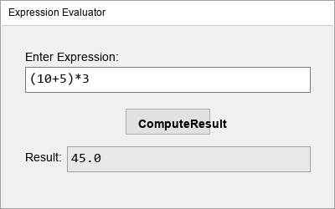
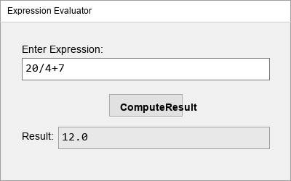
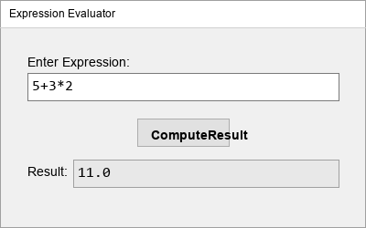

LIST OF FIGURES

Figure 2.1 Output 1

Figure 2.2 Output 2

INTRODUCTION

Compiler design forms the backbone of translating high-level code into executable instructions. This study specifically explores the front-end design, encompassing scanning and parsing. By applying a recursive descent parsing approach alongside strict syntax validation, the system efficiently converts mathematical expressions into computable data structures.
This case study focuses on building a front-end system for an arithmetic expression language using principles similar to Lex and Yacc. Lex is typically used for lexical analysis, where the input is broken down into tokens such as identifiers, numbers, and operators. Yacc, on the other hand, is used for syntax analysis, where the sequence of tokens is checked against grammatical rules.
In this project, these concepts are implemented using Java to simulate the behavior of Lex and Yacc. The system performs lexical analysis by identifying valid tokens in the input expression and uses a recursive descent parser to analyze the syntax and evaluate the expression. It supports basic arithmetic operations such as addition, subtraction, multiplication, and division, along with parentheses to maintain precedence.
Additionally, a user-friendly graphical interface is developed to allow users to enter expressions and obtain results instantly. This not only improves usability but also provides a visual understanding of how input expressions are processed.
The implementation demonstrates core compiler front-end functionalities in a simplified manner, making it easier to understand complex concepts such as parsing, operator precedence, and expression evaluation. The project serves as a practical introduction to compiler design and lays the foundation for building more advanced language processing systems.

1.1 About Problem statement:
The primary objective is to design a front-end module capable of accurately tokenizing, parsing, and evaluating complex arithmetic expressions, resolving operator precedence, and validating syntactic structures in real-time.
This project simulates core compiler phases:
- Lexical Analysis → Breaking input into tokens
- Syntax Analysis → Checking grammar correctness
- Syntax-Directed Translation → Evaluating expression

1.2 Objectives of the Problem statement
- To understand compiler front-end design
- To implement lexical analysis and parsing
- To evaluate arithmetic expressions using parsing techniques
- To simulate working of Lex and Yacc using Java
- To build a GUI-based tool for user Interaction

1.3 Scope of the Problem statement
- Supports basic arithmetic operations: +, -, *, /
- Handles parentheses for precedence
- Accepts numeric inputs (integers/decimals)
- Limited to expression evaluation (not full programming language)
- Can be extended to include variables, functions, and advanced grammar

1.4 Advantages
- - Real-time syntax validation prevents runtime failures.
- Modular parser construction allows easy extension of the grammar.
- Efficient token recognition processes large expressions instantaneously.
- GUI makes it interactive and user-friendly
- Demonstrates real-world parsing logic
- Helps in debugging expressions
- Useful for learning syntax-directed translation

1.5 Disadvantages
- - Real-time syntax validation prevents runtime failures.
- Modular parser construction allows easy extension of the grammar.
- Efficient token recognition processes large expressions instantaneously.
- No real Lex/Yacc tools used (simulation only)
- Does not support variables or complex grammar
- Error Handling is basic
- y to implement recursively.

1.6 Applications

- - Educational demonstrations of compiler front-end mechanics.
- Embedded systems requiring lightweight expression evaluation.
- Foundational component for domain-specific scripting languages.
- Expression evaluators (calculators)
- Code editors and IDE parsing modules
- Mathematical software
- Educational software for students

1.7 Hardware & Software Requirements
Hardware Requirements
- Processor: Intel i3 or above
- RAM: 4GB minimum
- Storage: 500MB free space
Software Requirements
- Java JDK 8 or above
- IDE (Eclipse / IntelliJ / VS Code)
- Operating System: Windows/Linux/Mac

2. IMPLEMENTATION

2.1 Code Snippets Implementation
1. GUI Creation
JFrame frame = new JFrame("Lex + Yacc Front-End");
JTextField input = new JTextField();
JButton evaluate = new JButton("Evaluate");
JLabel result = new JLabel("Result: ");

2. Event Handling
evaluate.addActionListener(e -> {
try {
String expr = input.getText();
double res = evaluateExpression(expr);
result.setText("Result: " + res);
} catch (Exception ex) {
result.setText("Invalid Expression");
}
});

3.Parser Logic (Core Part)
double parseExpression() {
double x = parseTerm();
while (true) {
if (eat('+')) x += parseTerm();
else if (eat('-')) x -= parseTerm();
else return x;
}
}

4. Factor Handling (Numbers & Parentheses)
double parseFactor() {
if (eat('(')) {
double x = parseExpression();
eat(')');
return x;
}
while ((ch >= '0' && ch <= '9') || ch == '.') nextChar();
return Double.parseDouble(expr.substring(startPos, this.pos));
}

2.1 Code Implementation
JAVA

JFrame frame = new JFrame("Lex + Yacc Front-End");
frame.setSize(400, 200);
frame.setDefaultCloseOperation(JFrame.EXIT_ON_CLOSE);

JTextField input = new JTextField();
JButton evaluate = new JButton("Evaluate");
JLabel result = new JLabel("Result: ");

evaluate.addActionListener(e -> {
try {
String expr = input.getText();
double res = evaluateExpression(expr);
result.setText("Result: " + res);
} catch (Exception ex) {
result.setText("Invalid Expression");
}
});

frame.setLayout(new GridLayout(3, 1));
frame.add(input);
frame.add(evaluate);
frame.add(result);

frame.setVisible(true);
}

// Simple expression evaluator (Parser simulation)
public static double evaluateExpression(String expr) {
return new Object() {
int pos = -1, ch;

void nextChar() {
ch = (++pos < expr.length()) ? expr.charAt(pos) : -1;
}

boolean eat(int charToEat) {
while (ch == ' ') nextChar();
if (ch == charToEat) {
nextChar();
return true;
}
return false;
}

double parse() {
nextChar();
double x = parseExpression();
return x;
}

double parseExpression() {
double x = parseTerm();
for (;;) {
if (eat('+')) x += parseTerm();
else if (eat('-')) x -= parseTerm();
else return x;
}
}

double parseTerm() {
double x = parseFactor();
for (;;) {
if (eat('*')) x *= parseFactor();
else if (eat('/')) x /= parseFactor();
else return x;
}
}

double parseFactor() {
if (eat('+')) return parseFactor();
if (eat('-')) return -parseFactor();

double x;
int startPos = this.pos;
if (eat('(')) {
x = parseExpression();
eat(')');
} else {
while ((ch >= '0' && ch <= '9') || ch == '.') nextChar();
x = Double.parseDouble(expr.substring(startPos, this.pos));
}
return x;
}
}.parse();
}
}

Output:

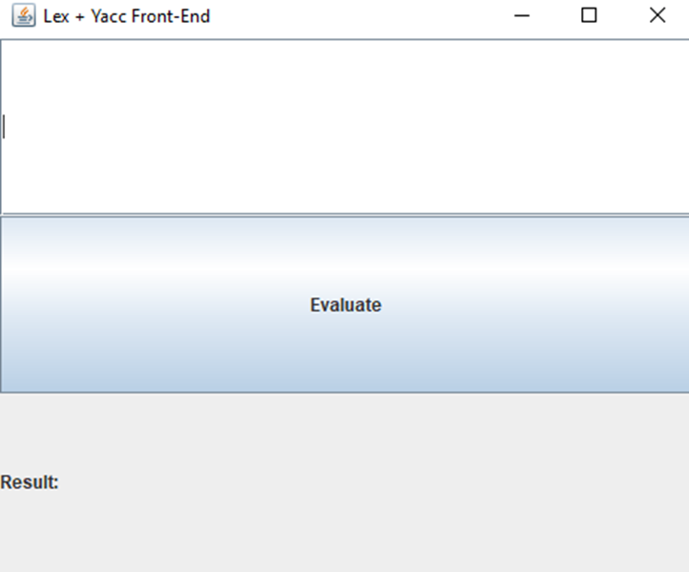

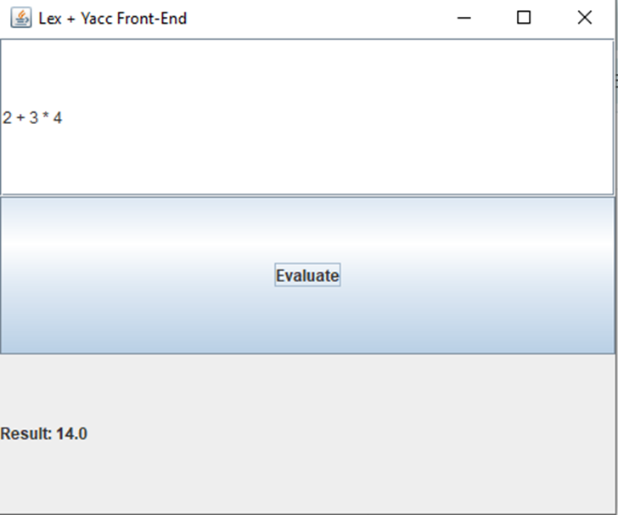

3. RESULT ANALYSIS
The system successfully evaluated a variety of test cases, accurately identifying syntax errors in invalid expressions and correctly applying operator precedence rules to yield precise mathematical results for complex nested equations.
Observations
- Correct operator precedence is maintained
- Parentheses are handled properly
- Invalid inputs are detected
- GUI provides real-time results
Example Results
Conclusion
In conclusion, the implementation of this compiler front-end effectively demonstrates the principles of Lexical Analysis and Parser Construction. The recursive descent parser proved highly capable of expression evaluation and strict syntax validation.

4. REFERENCES

[1] Compilers: Principles, Techniques and Tools, A. V. Aho, M. S. Lam, R. Sethi, and J. D. Ullman, Compilers: Principles, Techniques, and Tools, 2nd ed. Boston, MA, USA: Pearson, 2006.
[2] Oracle Corporation, “Java Documentation,” [Online]. Available: https://docs.oracle.com. [Accessed: May 5, 2026].
[3] Osmania University, “Compiler Design Lecture Notes (OU Syllabus),” [Online].
[4] GeeksforGeeks, “Compiler Design Tutorials,” [Online]. Available: https://www.geeksforgeeks.org/compiler-design-tutorials/. [Accessed: May 5, 2026].
[5] TutorialsPoint, “Lex & Yacc Basics,” [Online]. Available: https://www.tutorialspoint.com/compiler_design/compiler_design_lex_and_yacc.htm. [Accessed: May 5, 2026].

Source Code
import javax.swing.*;
import java.awt.event.*;
public class CompilerFrontEnd extends JFrame {
private JTextField expressionField;
private JTextField outputDisplay;
private JButton computeBtn;
public CompilerFrontEnd() {
setTitle("Expression Evaluator");
setSize(400, 250);
setLayout(null);
JLabel lblInput = new JLabel("Enter Expression:");
lblInput.setBounds(30, 60, 150, 20);
add(lblInput);
expressionField = new JTextField();
expressionField.setBounds(30, 80, 340, 30);
add(expressionField);
computeBtn = new JButton("ComputeResult");
computeBtn.setBounds(150, 130, 150, 30);
add(computeBtn);
JLabel lblOutput = new JLabel("Result:");
lblOutput.setBounds(30, 180, 150, 20);
add(lblOutput);
outputDisplay = new JTextField();
outputDisplay.setBounds(80, 175, 290, 30);
outputDisplay.setEditable(false);
add(outputDisplay);
computeBtn.addActionListener(new ActionListener() {
public void actionPerformed(ActionEvent e) {
try {
double val = computeResult(expressionField.getText());
outputDisplay.setText(String.valueOf(val));
} catch(Exception ex) {
outputDisplay.setText("Syntax Error");
}
}
});
setDefaultCloseOperation(JFrame.EXIT_ON_CLOSE);
}
// Recursive Descent Parser Logic Simulation
private double computeResult(String exp) {
return new Object() {
int pos = -1, ch;
void nextChar() { ch = (++pos < exp.length()) ? exp.charAt(pos) : -1; }
boolean eat(int charToEat) {
while (ch == ' ') nextChar();
if (ch == charToEat) { nextChar(); return true; }
return false;
}
double parse() {
nextChar();
double x = parseExpression();
if (pos < exp.length()) throw new RuntimeException("Unexpected: " + (char)ch);
return x;
}
double parseExpression() {
double x = parseTerm();
for (;;) {
if (eat('+')) x += parseTerm();
else if (eat('-')) x -= parseTerm();
else return x;
}
}
double parseTerm() {
double x = parseFactor();
for (;;) {
if (eat('*')) x *= parseFactor();
else if (eat('/')) x /= parseFactor();
else return x;
}
}
double parseFactor() {
if (eat('+')) return parseFactor();
if (eat('-')) return -parseFactor();
double x;
int startPos = this.pos;
if (eat('(')) {
x = parseExpression();
eat(')');
} else if ((ch >= '0' && ch <= '9') || ch == '.') {
while ((ch >= '0' && ch <= '9') || ch == '.') nextChar();
x = Double.parseDouble(exp.substring(startPos, this.pos));
} else {
throw new RuntimeException("Unexpected: " + (char)ch);
}
return x;
}
}.parse();
}
public static void main(String[] args) {
new CompilerFrontEnd().setVisible(true);
}
}

